

Version: 1.0.0

Release date: 25-11-2016

Riccardo Cattaneo 873647

Fabio Chiusano 874294

PowerEnJoy, Design Document

Table of Contents

1 Introduction 3

1.1 Purpose 3

1.2 Scope 3

1.3 Definitions, Acronyms, Abbreviations 3

1.4 Reference Documents 3

1.5 Document Structure 3

2 Architectural Design 5

2.1 Overview 5

2.2 High Level Components and their interactions 6

2.2.1 Overview 6

2.2.2 Technologies used 7

2.3 Component view 8

2.3.1 Main server component view 8

2.3.2 User component view 8

2.3.3 Car component view 8

2.4 Deployment view 9

2.5 Runtime view 9

2.6 Component interfaces 9

2.6.1 Main server component interfaces 9

2.6.2 User component interfaces 10

2.6.3 Car component interfaces 10

2.7 Selected architectural styles and patterns 11

2.8 Other design decisions 11

2.9 Extra: class diagrams for main server components 12

2.9.1 User related 12

2.9.2 Reservation related 12

2.9.3 Search related 13

3 Algorithm Design 14

4 User Interface Design 15

5 Requirements Traceability 16

6 Effort spent 22

7 References 23

# Introduction

## Purpose

This document describes the hardware and software architecture of the PowerEnjoy System. Therefore, it outlines hardware tiers and all parts of the software and how they will work and cooperate together.

In particular, this document contains information about:

* Architecture Design with related pattern used;
* Main components and software interface design;
* Runtime behaviour of the system
* User Interface Design

## Scope

PowerEnjoy is a car-sharing service based on a mobile web application.

It allows the user to see, thanks to the help of an external search-on-a-map handler, where the electric cars are, only if they are close to an address provided by either the user or his/her GPS Location.

Hence, it allows users to reserve an electric car and to get on board when he/she is close to it.

The car software takes into account the minutes of usage of the car, the number of passengers, the battery level and the location of release.

The system then calculates the charges the user for the ride.

The main purpose of the system is to create a new and smart car-sharing service, that incentivize virtuous and green behaviours.

## Definitions, Acronyms, Abbreviations

* DD: Design document.
* RASD: Requirements Analysis and Specification Document.
* JSE: Java Serial Edition.
* JEE: Java Enterprise Edition.

## Reference Documents

## Document Structure

This document specifies the architecture of PowerEnJoy spreading from the general into the specific. Also it describes the architectural decisions and tradeoffs and justifies them. The design was guided by a top-down process approach and the document structure reflects this tactic.

The document is organized as follows:

1. Introduction, provides a synopsis of the architectural descriptions.
2. Architectural design, provides a general description of PowerEnJoy including its functionality and matters related to the overall system and its design.
3. Algorithmic design.
4. User Interface design.
5. Requirements traceability.
6. Effort spent.

# Architectural Design

## Overview

We propose to make a web app that will give users a comfortable way to use our service. The reasons according to which we have chosen a web app instead of the web site are explained in the “Proposed system” chapter of the RASD document.

The architecture of PowerEnjoy Service has three tier:

* The presentation will be provided to the user thanks to the cooperation between the client and the Web Tier of the Server;
* The Logic will be provided by the Main Server;
* The Persistence functionalities will be provided by a Database Server, which communicate directly to the Main Server.



Client Tier

Presentation Tier

Mobile Web-App

Web Tier

Presentation Tier

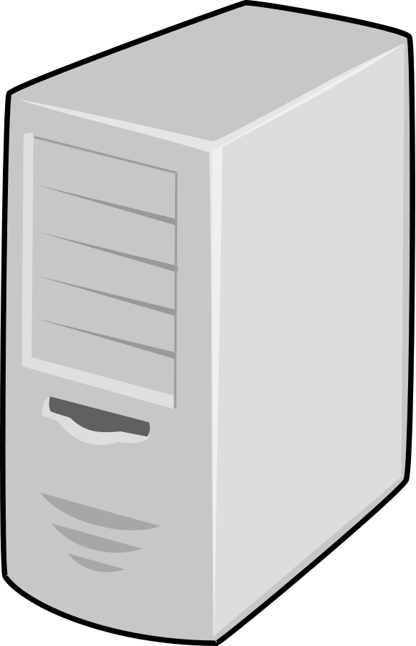

Business Tier

Business Logic Tier

Main Server



EIS Tier

Database Tier

Database Server

## High Level Components and their interactions

### Overview

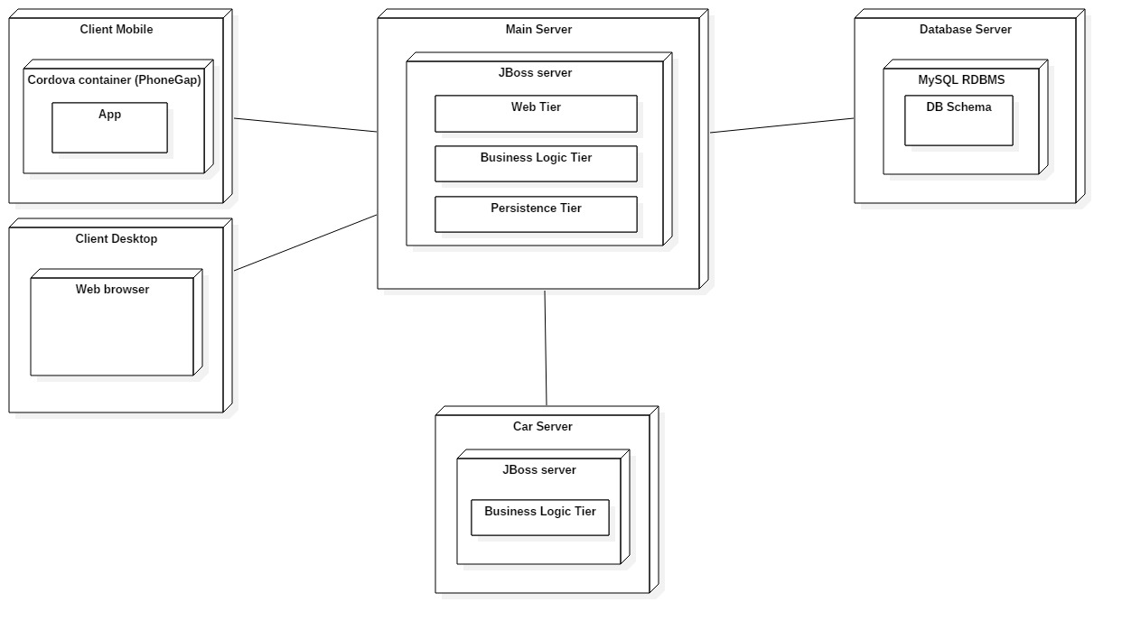

* Client Tier, represented by the web app, that will be available to all the major mobile operating systems and will be developed in a way to communicate with the PowerEnjoy servers through RESTful API and HTTP requests, consequently the front-end will lie on the server;
* On the server side, the Main Server contains two software tiers:
  + Web Tier, that manages the communication with the web app.

It receives requests from the app and provides it and updated front-end, thanks to JavaServerPages (JSP);

* + Business Logic Tier, that elaborates requests from client thanks to the embedded logic and manages interactions with Database, thanks to the Java Percistence API (JPA);
* Database Tier, that contains and manages persistent data in an efficient way.

Of course, the electric cars must be able to communicate with the server, so they must be provided with an Internet connection and an on-board computer that must be able to run Java software. Cars will have small logic, mainly dedicated to communicate sensors data with Logic Tier of the Main Server.

The Main Server will also take advantage of external handler, such as Payment Handler and Search-on-a-map Handler, in order to manage successfully functionalities provided to users.

### Technologies used

* The web app will be implemented using PhoneGap framework:
  + Interactions with the Server will be done via HTTP calls, using RESTful services offered;
* The Main Server will be implemented with Java Enterprise Edition (JEE):
  + Communication with the web app will be possible thanks to Java API for RESTful Web Services (JAX-RS);
  + The front-end functionalities, that clients need, will be provided with Java Server Pages (JSP);
  + Business Logic will be implemented using Session Java Beans, and communication with WebTier will be managed with the EJB Container;
  + Data management and interaction with Database Server will be implemented thanks to Java Persistence API (JPA), and will be composed of Entity Java Beans;
* For the Database Server we will use MySQL.

## Component view

### Main server component view

### User component view

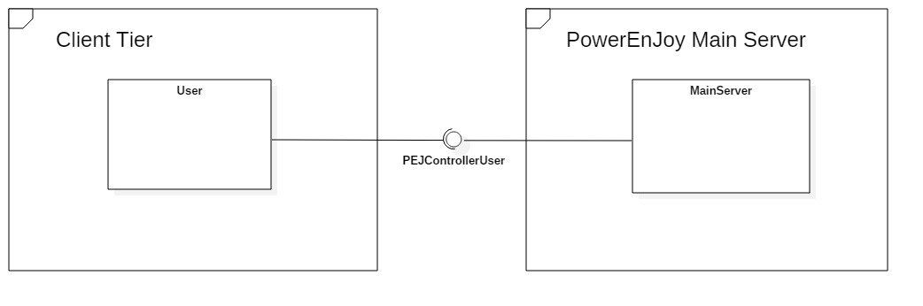

### Car component view

## Deployment view

## Runtime view

### Log-in Sequence Diagram

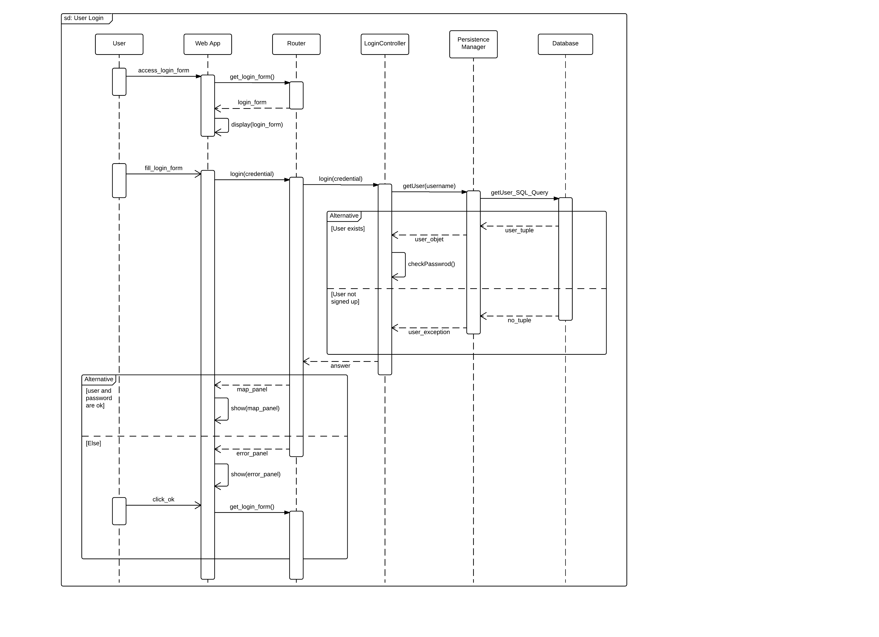

This sequence diagram represents the user login.

The user has to select to login and fulfil the form with his credential.

The login request is then sent to the server. Once arrived to the system’s router, the request is transferred to the LoginController, which first requires user information to the persistence tier. Then checks if the user exists or, if it does, checks if the password is correct. The web app receives either the map panel if credential was correct or an error panel if it was not, and display it to the user. If the user has to insert again credential, the app then displays again the login panel.

### Show Special Safe Areas with Power Grids

This sequence diagram represents interactions between components in order to provide the user a map filled with Safe Areas with Power Grids in the right positions.

After user has chosen to go to the map page, system provides him a paged with a map centred in a default address. Then, thanks to the GPS sensor or, as in this case, after that the user has fulfilled the address field, the system loads the map centred on the address provided. This process can happen thanks to the interaction between the MapController, in PowerEnjoy Main Server, and the search-on-a-map handler.

Then, the user selects to show positions of Power Grids. The request is moved to the MapController, which gets Power Grids Positions from the database, elaborates the map image overlaying a symbol in each position, and sends the answer back with the help of above layers. If there are not Power Grid within a certain defined range, the user gets an error message.

### Reserve a Car

This sequence diagram represents the reservation of a car. We assume that the user has already logged-in and selected a Safe Area with at least one available car.

After user has selected one of them, the system provides him a page with all the information about that car. In this example, the Search Controller provides the information about battery level and if the car is plugged or not, but there can be many other. Then, the Reservation Controller deals with the creation of a new reservation. Thanks to the Car Controller, a Reservation Code is displayed on the interior screen of the car in order to give the ability to the user to unlock it. The Reservation Controller deals also with the creation of a timer that checks if a reservation should be expired or not, and manages consistency of data, marking the car as not available anymore.  
Finally the system informs the user about the reservation created.

### Unlocking the Reserved Car

This sequence diagram is about unlocking of a car by the user who reserved it. We assume that the user has already logged-in and the reservation has not expired.

After user has inserted the code shown on the screen inside the car, the Reservation Controller find the active reservation for that user and check if the code is right. If it is, the car is unlocked by Car Controller and the System start charging user. Otherwise, an error message is shown to the user.

### End of a Ride

This sequence diagram describes system interactions when a user exits the car and finish a ride. A cooperation between controllers is needed in order to achieve data consistency and to perform the payment.

## Component interfaces

### Main server component interfaces

### User component interfaces

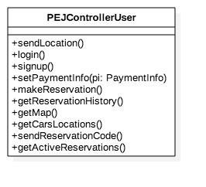

### Car component interfaces

## Selected architectural styles and patterns

Three tiers, event-based, MVC…

## Other design decisions

Maybe data model (class diagrams, Object Relationship diagrams) and data storage (ER diagrams, SQL stamements for tables creation).

## Extra: class diagrams for main server components

### User related

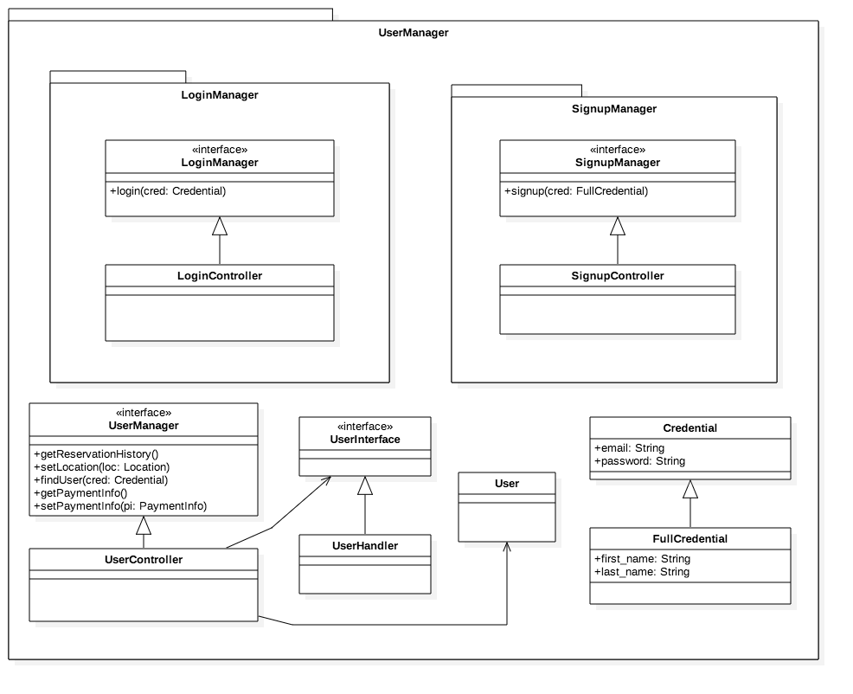

### Reservation related

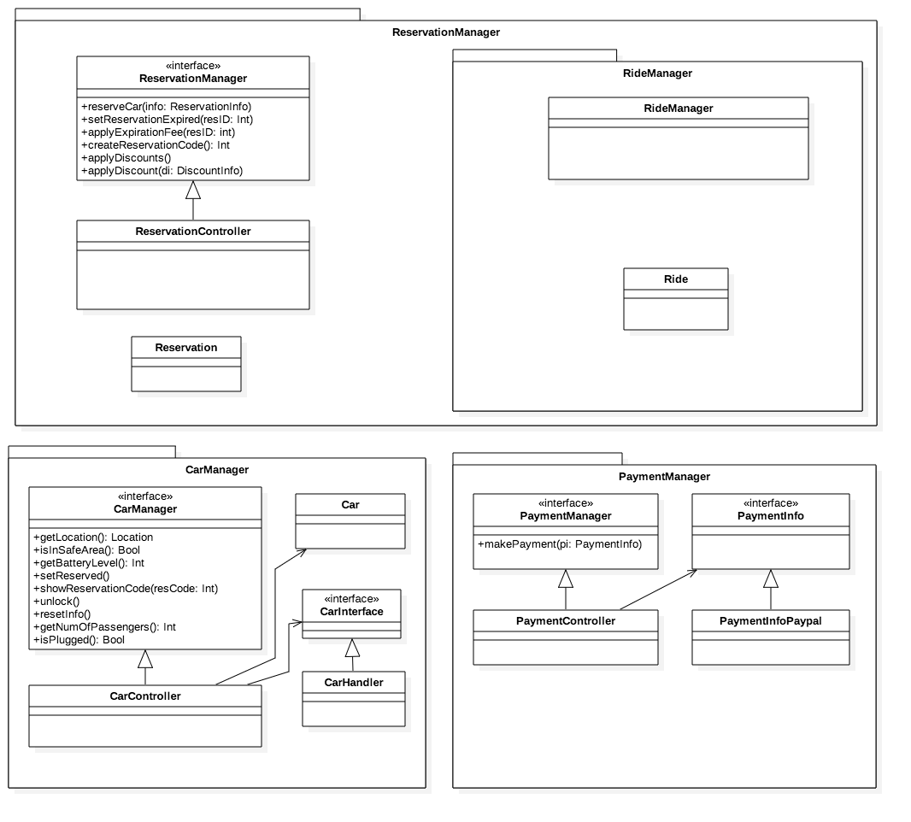

### Search related

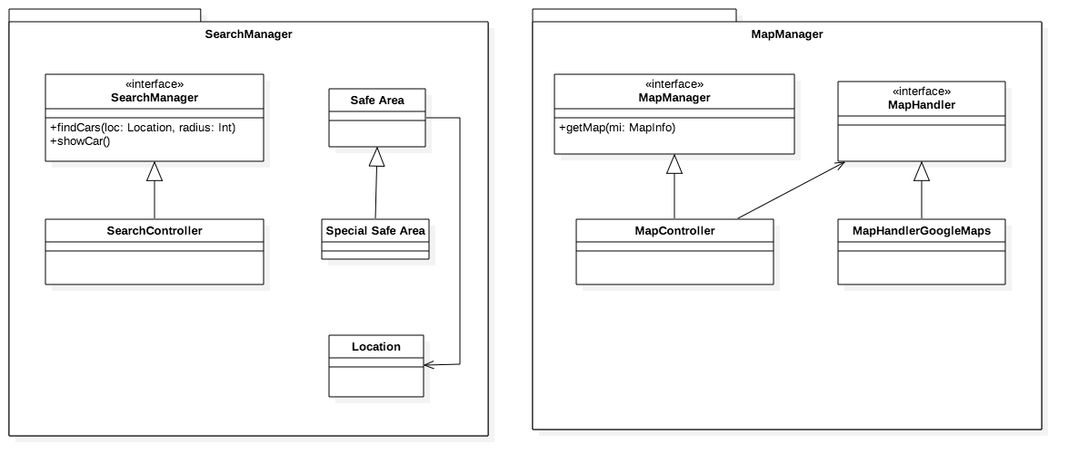

# Algorithm Design

An interesting and important algorithm is the one related to the search for near cars.

It may be too expensive comparing the distances between the user location and the location of each car in the database.

An important thing to point out of our system is that the database stores the cars locations, but they are not constantly updated. Indeed, they are updated only at the end of the ride of a reservation. This implies that cars locations in the database are reliable only when a car is parked in a safe area without an active reservation. However, this is exactly the moment in which such cars must be shown to the users.

In order to do this efficiently, we’ll use spatial data structures.

Consider this map of Milan.

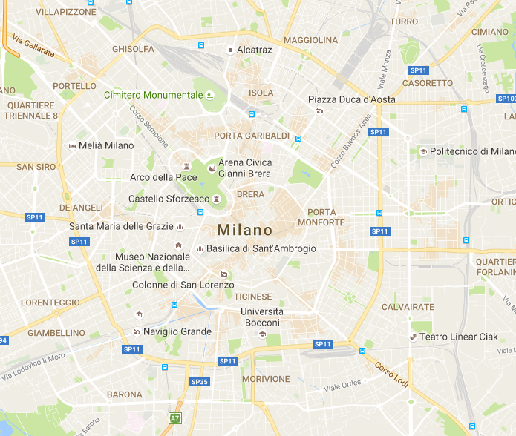

Now, this is the same map but with the PowerEnJoy cars drawn on it.

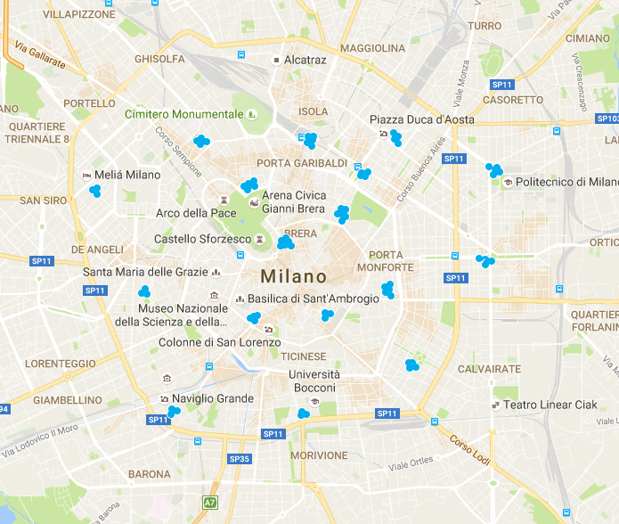

There is a total of 17 parkings drawn. However, PowerEnJoy will probably have more.

Instead of comparing the distance between the user condition and the locations of all the cars of our system in Milan, we can split Milan in sectors, as shown in the next image.

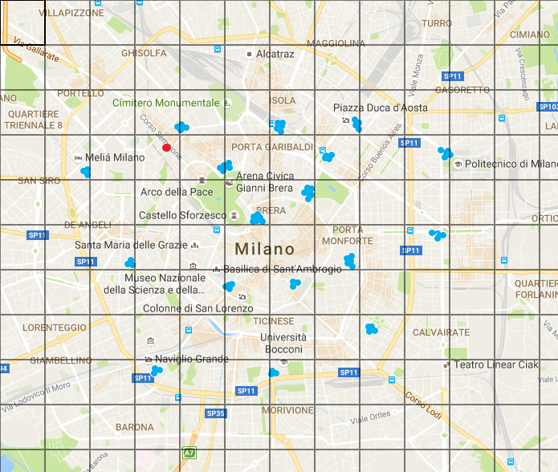

0

1

2

3

4

…

0 1 2 3 4 …

The red circle is the user position.

In order to find the near cars, we just have to check which cars belong to the sections near the user position.

The user is in section S(3, 3). Suppose we are interested in cars near the user in a radius of 2km and each square has side long 1km.

Then, we should check cars in the same section of the user and in the sections around it that intersect with the circumference with radius 2km and the user position as center. The sections we’ll check are S(2, 2), S(2, 3), S(2, 4), S(3, 2), S(3, 3), S(3, 4), S(4,2), S(4, 3) and S(4, 4). In this way we only consider 7 cars out of the total 50+ cars.

The downsides of this algorithm are:

1. There should be always a matrix allocated containing all the sectors. A matrix represent a big city and therefore it would be difficult to find near cars if we found ourselves in positions near its borders.
2. More is the section sides length, more is the precision of our algorithm in cutting off cars from the computation (more speed), but it will need more memory to memorize the big number of sectors (less memory). This works viceversa too.
3. We should allocate cars to sectors in a continuous way. However, since we are interested in the cars positions only when they are available, it will be enough to update their position in the database only at the end of a ride. Therefore this is not a downside in our case.

It is possible to solve the first downside by organizing sectors in a hierarchical way. Consider the following image of a part of Lombardia.

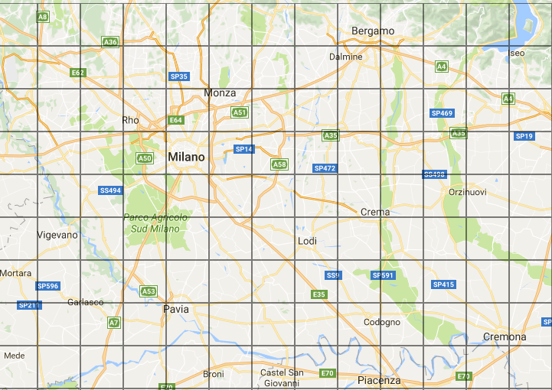

The sector of Milan will contain the matrix of such city that we previously saw.

 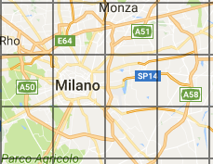

Another advantage of organizing sectors in a hierarchical way is that we are not forced to always use the same sector side length. For example, if Milan is more densely populated with cars of our system than Bergamo, then we can use a smaller sector side length for Milan in order to increase the number of cars that will be cut off during searches.

This fact doesn’t solve completely the second downside, but give us more control on the tradeoff between speed and memory.

This hierarchy can of course be seen as a tree. With a careful implementation, it’s possible to inject different types of matrix in the same one (i.e. some sectors of Lombardia can be expandible in other sectors and others don’t).

We can now provide the pseudocode for our data structures and for the search of near cars.

public class SectorCar {

private int id;

private double latitude;

private double longitude;

private LeafSector sector;

/* Getters and setters */

…

}

public interface Sector {

// Returns true if contains a list of cars, false if contains a matrix of other sectors.

boolean isLeafSector();

// Also updates car.sector.

void addCar(SectorCar car);

void removeCar(int carID);

}

public class LeafSector implements Sector {

private List<SectorCar> cars;

public LeafSector() { … }

public boolean isLeafSector() {

return true;

}

public void addCar(SectorCar car) { … }

public void removeCar(int carID) { … }

}

public class NodeSector {

private int sideLength; // in km

private int rows;

private int cols;

private Sector[][] matrix;

// By default, each Sector it’s a LeafSector.

public NodeSector (int rows, int cols, int sideLength) { … }

/* Getters and setters */

…

public boolean isLeafSector() {

return false;

}

public void addCar(SectorCar car) { … }

public void removeCar(int carID) { … }

// This method does two things:

1 - it finds the previous sector of the car by doing car.sector and removes the car from its list.

2 - it finds the new sector of the car using latitude and longitude and assigns the car to this sector.

void updateCarPosition(SectorCar car, double latitude, double longitude);

/* The following method replace a sector with another one.

There are different cases:

- LeafSector -> LeafSector: useless.

- LeafSector -> NodeSector: we want more precision in such area. All the SectorCar are reassigned to the right Sector.

- NodeSector -> LeafSector: we want less precision. All the cars in the NodeSector will be assigned to the LeafSector.

- NodeSector -> NodeSector: some variables between rows, cols and sideLength may vary. In this case, all the SectorCar are reassigned to the right Sector. */

public void replaceSector(Sector newSector, int row, int col) { … }

}

/* This class contains the NodeSector that contains the area in which our system operates */

public class CarTreeSingleton {

private static CarTreeSingleton instance;

private NodeSector root;

private Map<Integer, SectorCar> sectorCarMap;

private CarTreeSingleton() {

this.instance = new CarTreeSingleton();

this.instance.root = new NodeSector(TREE_SECTOR_ROWS, TREE_SECTOR_COLS, TREE_SECTOR_SIDELENGTH);

this.instance.sectorCarMap = new HashMap<Interger, SectorMap>();

}

public static CarTreeSingleton getInstance() { … }

public NodeSector getRoot() { … }

public Map<Integer, SectorCar> getSectorCarMap() { … }

}

In the following code, we fill the CarTreeSingleton for the first time (to be done when the server launches).

CarTreeSingleton cts = CarTreeSingleton.getInstance();

NodeSector root = cts.getRoot();

Map<Integer, SectorCar> sectorCarMap = cts.getSectorCarMap;

foreach Car car in database {

SectorCar sectorCar = new SectorCar(car.id, car.latitude, car.longitude);

root.addCar(sectorCar);

sectorCarMap.put(car.id, sectorCar);

}

The following code instead shows how to substitute a LeafSector with a NodeSector, so that more precision can be achieved in that area.

CarTreeSingleton cts = CarTreeSingleton.getInstance();

NodeSector root = cts.getRoot();

NodeSector sectorMilan = new NodeSector(rows, cols, sideLength);

root.replaceSector(sectorMilan, sectRow, sectCol);

Finally, the following code shows how to update the position of a car.

public void onRideConcluded(Ride ride, …) {

int carID = ride.car.id;

int carLatitude = ride.car.latitude;

int carLongitude = ride.car.longitude;

CarTreeSingleton cts = CarTreeSingleton.getInstance();

NodeSector root = cts.getRoot();

Map<Integer, SectorCar> sectorCarMap = cts.getSectorCarMap;

SectorCar sectorCar = sectorCarMap.get(carID);

root.updateCarPosition(sectorCar, carLatitude, carLongitude);

}

The problem is now divided in many easier subproblems. The most difficult methods to implement are NodeSector::updateCarPosition and NodeSector::replaceSector. They are explained in their comments and can be easily implemented with the help of Sector::addCar and Sector::removeCar and by making some comparisons with the dimensions of the varius sectors.

It would be great to make the system automatically manage the sectors hierarchy in order to achieve performance closer to optimum without human intervention.

This can be done, for example, by finding simple and efficient rules such as “when a LeafSector contains more than 20 cars, replace it with a NodeSector whose matrix is 3x3” and “when a NodeSector contains less than 10 cars in total, replace it with a LeafSector”. Such sector transformations may occur after each concluded ride or at specific instances of time during the day. Some performance testing are necessary.

# User Interface Design

# Requirements Traceability

The following tables show how each requirement specified in the RASD document is satisfied by the architecture proposed. The *components* and *description* columns give and idea of all the functions involved.

* [G1] *Users can see and select an available car close to him, or close to a specified address, and reserve it for up to one hour before they pick it up.*

|  |  |  |
| --- | --- | --- |
| REQUIREMENT | COMPONENTS | DESCRIPTION |
| R1: The system has to detect if a car is parked in a Safe Area | Car server:   * GPSController   Main server:   * CarController | Car server:   * GPSController.getLocation   Main server:   * CarController.getLocation, * CarController.isInSafeArea |
| R2: The system has to detect the battery level of each car | Car server:   * CarInfoController   Main server:   * CarController | Car server:   * CarInfoController.getBatteryLevel   Main server:   * CarController.getBatteryLevel |
| R3: The system has to detect car position and display it on the map | User browser/app:   * PEJControllerUser   Car server:   * GPSController   Main server:   * MapController, * CarController, * SearchController | User browser/app:   * PEJControllerUser.getMap * PEJController.getCarsLocations   Car server:   * GPSController.getLocation   Main server:   * MapController.getMap, * CarController.getLocation, * SearchController.showCar |
| R4: The system has to be able to identify the location of a user or through his/her GPS, if he/she gives the consent, or through some input | User browser/app:   * PEJControllerUser | User browser/app:   * PEJControllerUser.sendLocation |
| R5: The system has to provide a list of available cars close to a given address | Main server:   * SearchController | Main server:   * SearchController.findCars |
| R6: The system has to give the possibility to reserve a car at most by one user at a time | User browser/app:   * PEJControllerUser   Main server:   * ReservationController, * CarController   Car server:   * DashboardController | User browser/app:   * PEJControllerUser.makeReservation   Main server:   * ReservationController.reserveCar, * ReservationController.createReservationCode, * CarController.setReserved   Car server:   * DashboardController.showReservationCode |
| R7: The system has to mark the reservation as expired for a car after one hour if the user has not picked it up | Main server:   * ReservationController (+ JEE Timer Service) | Main server:   * ReservationController.setReservationExpired |
| R8: The system has to apply a fee of 1€ if the reservation has expired | Main server:   * ReservationController | Main server:   * ReservationController.applyExpirationFee |

* [G2] *Users can get in a car only if they are near it and they reserved it.*

|  |  |  |
| --- | --- | --- |
| REQUIREMENT | COMPONENTS | DESCRIPTION |
| R1: Cars, if reserved, should show a reservation code on their dashboard | Main server:   * CarController   Car server:   * DashboardController | Main server:   * CarController.showReservationCode   Car server:   * DashboardController. showReservationCode |
| R2: The system has to unlock the car if the user that reserved it sends the reservation code to the system | User browser/app:   * PEJControllerUser   Main server:   * CarController   Car server:   * CarInfoController | User browser/app:   * PEJControllerUser.sendReservationCode   Main server:   * CarController.unlock   Car server:   * CarInfoController.lockDoors |

* [G3] *Users should pay proportionally to minutes they have used the car, and they should see in real time the amount of the bill.*

|  |  |  |
| --- | --- | --- |
| REQUIREMENT | COMPONENTS | DESCRIPTION |
| R1: The system has to reset trip information when a user get on the car | Main server:   * CarController   Car server:   * TaximeterController * DashboardController | Main server:   * CarController.resetInfo   Car server:   * TaximeterController.reset * DashboardController.hideReservationCode |
| R2: The system has to be able to understand when the car engine ignites | Car server:   * PEJControllerCar | Car server:   * PEJControllerCar.engineOn |
| R3: The system has to start charging the user when the car engine ignites | Car server:   * TaximeterController | Car server:   * TaximeterController.start |
| R4: The system has to display the current charge | TaximeterSystem | The taximeter system is configured to always show its current value when active |
| R5: The system has to identify when a car is parked in a safe area | Main server:   * CarController   Car server:   * GPSController | Main server:   * CarController.getLocation * CarController.isInSafeArea   Car server:   * GPSController.getLocation |
| R6: The system has to identify when there is no one sit in the driver’s seat | Car server:   * SeatSensorController | Car server:   * SeatSensorController.isSeatUsed |
| R7: The system has to stop charging the user when the car is parked in a safe area and there is no one sat in the driver’s seat | Car server:   * SeatSensorController, * GPSController, * CarInfoController, * TaximeterController * PEJControllerCar | Car server:   * SeatSensorController.isSeatUsed, * GPSController.getLocation, * CarInfoController.isEngineOn, * TaximeterController.stop * TaximeterController.getVaule, * PEJControllerCar.rideFinished |

* [G4] *Users can register to the system and have their personal area.*

|  |  |  |
| --- | --- | --- |
| REQUIREMENT | COMPONENTS | DESCRIPTION |
| R1: The system has to provide log-in functionalities to the users:   * The user should be able to check his/her active reservations | Main server:   * LoginController, * UserController   User browser/app:   * PEJControllerUser | Main server:   * LoginController.login, * UserController.findUser   User browser/app:   * PEJControllerUser.login * PEJControllerUser.getActiveReservations |
| R2: The system has to provide sing-up form to users:   * The system has to check that there are not two users with the same username * The system has to store the password and personal information of every user * The system has to provide the possibility to enter a payment method * The system has to check if the payment method provided by the user is valid and usable | Main server:   * SignupController, * UserController, * PaymentController   User browser/app:   * PEJControllerUser | Main server:   * SignupController.signup, * UserController.findUser, * PaymentController.setPaymentInfo   User browser/app:   * PEJControllerUser.signup |
| R3: The system has to provide the possibility to change personal information or payment methods even after the registration | Main server:   * UserController, * PaymentController   User browser/app:   * PEJControllerUser | Main server:   * UserController.findUser, * PaymentController.setPaymentInfo   User browser/app:   * PEJControllerUser.setPaymentInfo |
| R4: The system has to provide the possibility to each user to see the personal “Reservation History” | User browserapp:   * PEJControllerUser   Main server:   * UserController | User browser/app:   * PEJControllerUser.getReservationHistory   Main server:   * UserController.getReservationHistory |

* [G5] *Virtuous behaviours by users should be incentivized.*

|  |  |  |
| --- | --- | --- |
| REQUIREMENT | COMPONENTS | DESCRIPTION |
| R1: The system has to apply a discount of 10% on the final bill if there were at least three passengers on the last ride:   * The system has to identify and store how many passengers there were on the car in the last ride | Main server:   * ReservationController, * CarController   Car server:   * SeatSensorController | Main server:   * ReservationController.applyDiscounts * ReservationController.applyDiscount, * CarController.getNumOfPassengers   Car server:   * SeatSensorController.numOfSeatsUsed |
| R2: The system has to apply a discount of 20% on the final bill if the car is left with at least 50% of battery level   * The system has to be able to identify the battery level of the car | Main server:   * ReservationController, * CarController   Car server:   * CarInfoController | Main server:   * ReservationController.applyDiscounts * ReservationController.applyDiscount, * CarController.getBatteryLevel   Car server:   * CarInfoController.getBatteryLevel |
| R3: The system has to apply a discount of 30% on the final bill if the car is left plugged-in in a Special Safe Area:   * The system has to identify if the car is plugged-in | Main server:   * ReservationController, * CarController   Car server:   * CarInfoController | Main server:   * ReservationController.applyDiscounts * ReservationController.applyDiscount, * CarController.getLocation * CarController.isPlugged   Car server:   * CarInfoController.isPlugged |
| R4: The system has to apply an extra-charge of 30% on the final bill if the car is left at least 3Km from the nearest Special Safe Area and the battery level is less than 30%:   * The system has to be able to calculate the distance between the actual position of the car and the nearest Special Safe Area | Main server:   * ReservationController, * CarController   Car server:   * GPSController * CarInfoController | Main server:   * ReservationController.applyDiscounts * ReservationController.applyDiscount, * CarController.getLocation   Car server:   * GPSController.getLocation * CarInfoController.getBatteryLevel |

# Effort spent

# References